The fifth tab on the Payment History screen is the On Hold Payments tab. This section shows payments that have been placed on hold.

As a precaution, SLP will hold payments in certain instances. Such as a member is on EZPay and calls the IVR system to make an over the phone payment. SLP will hold both payments to ensure the member doesn’t get charged twice.

Please know however, the member will get a confirmation number with the IVR but SLP will hold the payment.

If a payment is on hold, there is a do not cancel waiver on file to ensure members are not terminated for non-payment. Members do not have the capability to remove a hold, this must be done internally. To remove a help payment, please send an email to: TPA-DST-ProcessingReports@HealthPlan.com. Be sure to have the following content prior to submission:
- Subject Line: On Hold Payment Release
- Member name
- Individual List Bill
- Member ID number (if applicable)
- Received date of payment
- Payment method
- Hold code
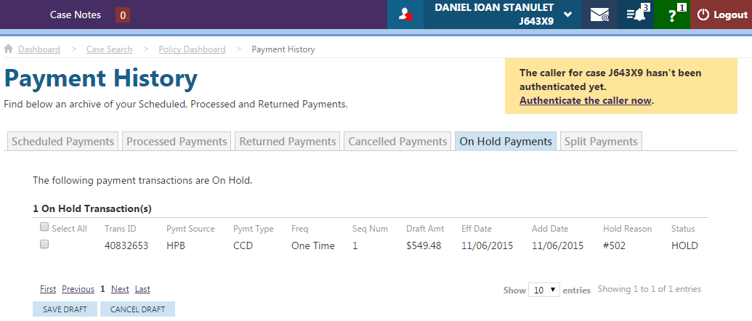

Field | Description
Select All | Check boxes appear when payment is on hold.
Trans ID | Transaction ID provided by the bank.
Pymt Source | The following Payment Sources will be displayed based on source type:  •Binder Payment  • Issue Payment  • IVR Payment  • Legacy Recurring Payment  • Pay Calendar Recurring Payment  • Post  • Refund  • Web Payment
Pymt Type | The following payment types will be displayed based on type:  •Credit Card  • EFT  • Prearranged payment and deposit entry  • IVR  • WEB  • Post Only
Freq | R = Recurring  O = Onetime  I = Initial (Binder)
Seq Num | The order in which it was submitted.
Draft Amt | Amount scheduled to draft.
Eff Date | Date scheduled to draft.
Add Date | Date added to the Hold report.
Hold Reason | Reason for the hold. Click here to view all hold reasons.
Status | HOLD = Payment on hold (only option).

